Fluid Forces
Names
Institution
Date

Fluid Forces
Forces of fluids are involved in helping or hindering an athlete. Swimmers profoundly apply hydrostatic pressure and buoyancy in fluid resistance so that they maximize their propulsion. Most sports are affected by the forces produced by fluids (Young et al., 2010). The forces that move through fluids flows meaning they travel in their initial direction. When an athlete is in contact with the water surface, the water or air moves or flows around him or her. This type of flow generates different forces whereby some forces will drag or slow down the athlete's movement while other effects will create buoyancy, lift or a spin. However, air is not dense or thick like water but acts as fluids. Air and water smoothly flow and contributes to the athlete's shape. Therefore, air and water tend to exert similar forces. These forces include hydrostatic pressure, lift, and drag, and buoyancy (Young et al., 2010).
The fluid forces of hydrostatic pressure affect athletes as they move through the fluid by exerting force when supporting the weight of the athlete (Fung, 2013). Hydrostatic pressure in air presses down the athlete's body since the gravitation pull is responsible at pulling down the atmosphere which delivers fluid onto the earth's surface. Therefore, most sporting activities are done close to the level of the sea since there is a minimal influence of atmospheric pressure (Fung, 2013).
The diagram below illustrates how hydrostatic pressure increases or reduces depending on how far a swimmer is submerged in a fluid.
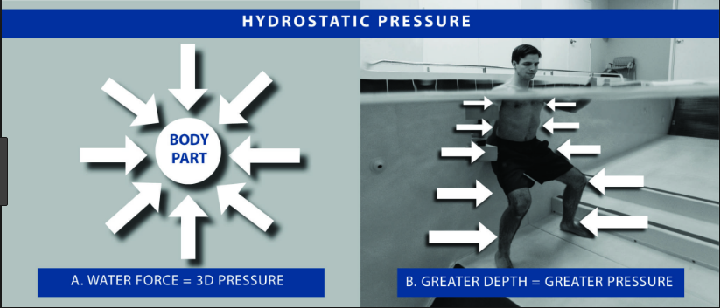
Buoyancy in the air affects objects as they make movements through fluids by creating an uplifting force that acts on an object. When buoyancy acts on an object, the object balances against the downward pull of gravity (Tu et al., 2018). Buoyancy in water affects how objects or athletes make movements through fluids by creating an uplifting force that is generated to counter gravitational force that pushes a submerged object in an upward direction. When an athlete is immersed in water, water tends to press on the athlete from all directions. It is because the pressure in water increases with depth; hence more pressure pushes on the athlete from below than from above or on the sides (Tu et al., 2018). Therefore, the result of buoyancy is it creates a powerful upward force that pushes on the athlete from below.
The picture below illustrates when buoyant force is larger than the gravitational force.
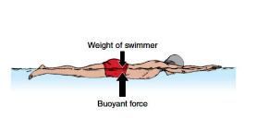
Drag and lift occur when an athlete or object is moving through air or water, then the drag and lift forces combine to create a resistance force (Goff, 2013). The drag forces are always in the travel direction and drag or oppose against the motion. The lift forces are always perpendicular to the drag force. Athletes tend to manipulate their flight path to take advantage of both forces of drag and lift. Swimmers are required to double their velocity through water which involves both surface drag and drag that increases fourfold. Wave drag increases to the velocity cube; therefore, if a swimmer doubles his or her velocity, then the force generated by the swimmer increases to an eightfold (Goff, 2013).
The picture below shows the boundary layer around an object (ball) that is moving slowly through the air.
The picture below shows the boundary layer around an object (ball) that is moving slowly through air.
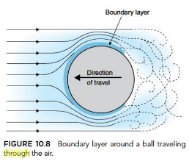
Apparently, moving with flow needs the concept whereby fluid flows around an athlete and the separated fluid particles become reconnected (Goff, 2013). An object or athlete moving through air or water is affected by the mechanical factors of hydrostatic pressure, buoyancy, drag and lift. The flow highly varies depending on the context of the movement either in water or air. Atmospheric pressure and temperature affect the action of water and air (Goff, 2013). When an object moves through a fluid, the drag and lift forces tend to combine to create a resultant force.

References
Fung, Y. C. (2013). Biomechanics: motion, flow, stress, and growth. Springer Science & Business Media.
Goff, J. E. (2013). A review of recent research into aerodynamics of sport projectiles. Sports engineering, 16(3), 137-154.
Tu, J., Yeoh, G. H., & Liu, C. (2018). Computational fluid dynamics: a practical approach. Butterworth-Heinemann.
Young, D. F., Munson, B. R., Okiishi, T. H., & Huebsch, W. W. (2010). A brief introduction to fluid mechanics. John Wiley & Sons.

